EASTERN INTERNATIONAL UNIVERSITY Practice Assignment – Quarter 1, 2024-2025
SCHOOL OF COMPUTING Course Name: Database
AND INFORMATION TECHNOLOGY Course Code: CSE 301
Student’s Full Name:
Lab 2
Student ID:

Using Draw.io
- You can access to https://www.drawio.com/ then you can chose “Start Now” to use the online version or “Dowload” to use the offline version.
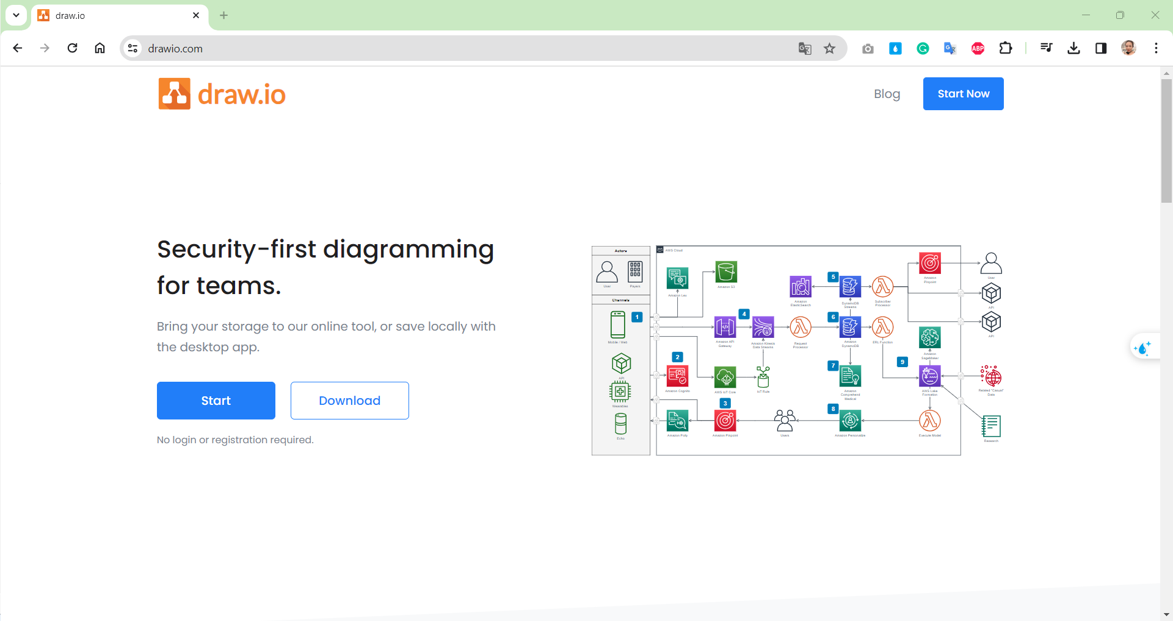
- Guiding to use online version for drawing ER diagram the following:
Chose “Creating new Diagram” -> “Entity Relationship Diagram” -> Create -> Set up name for Diagram -> Save
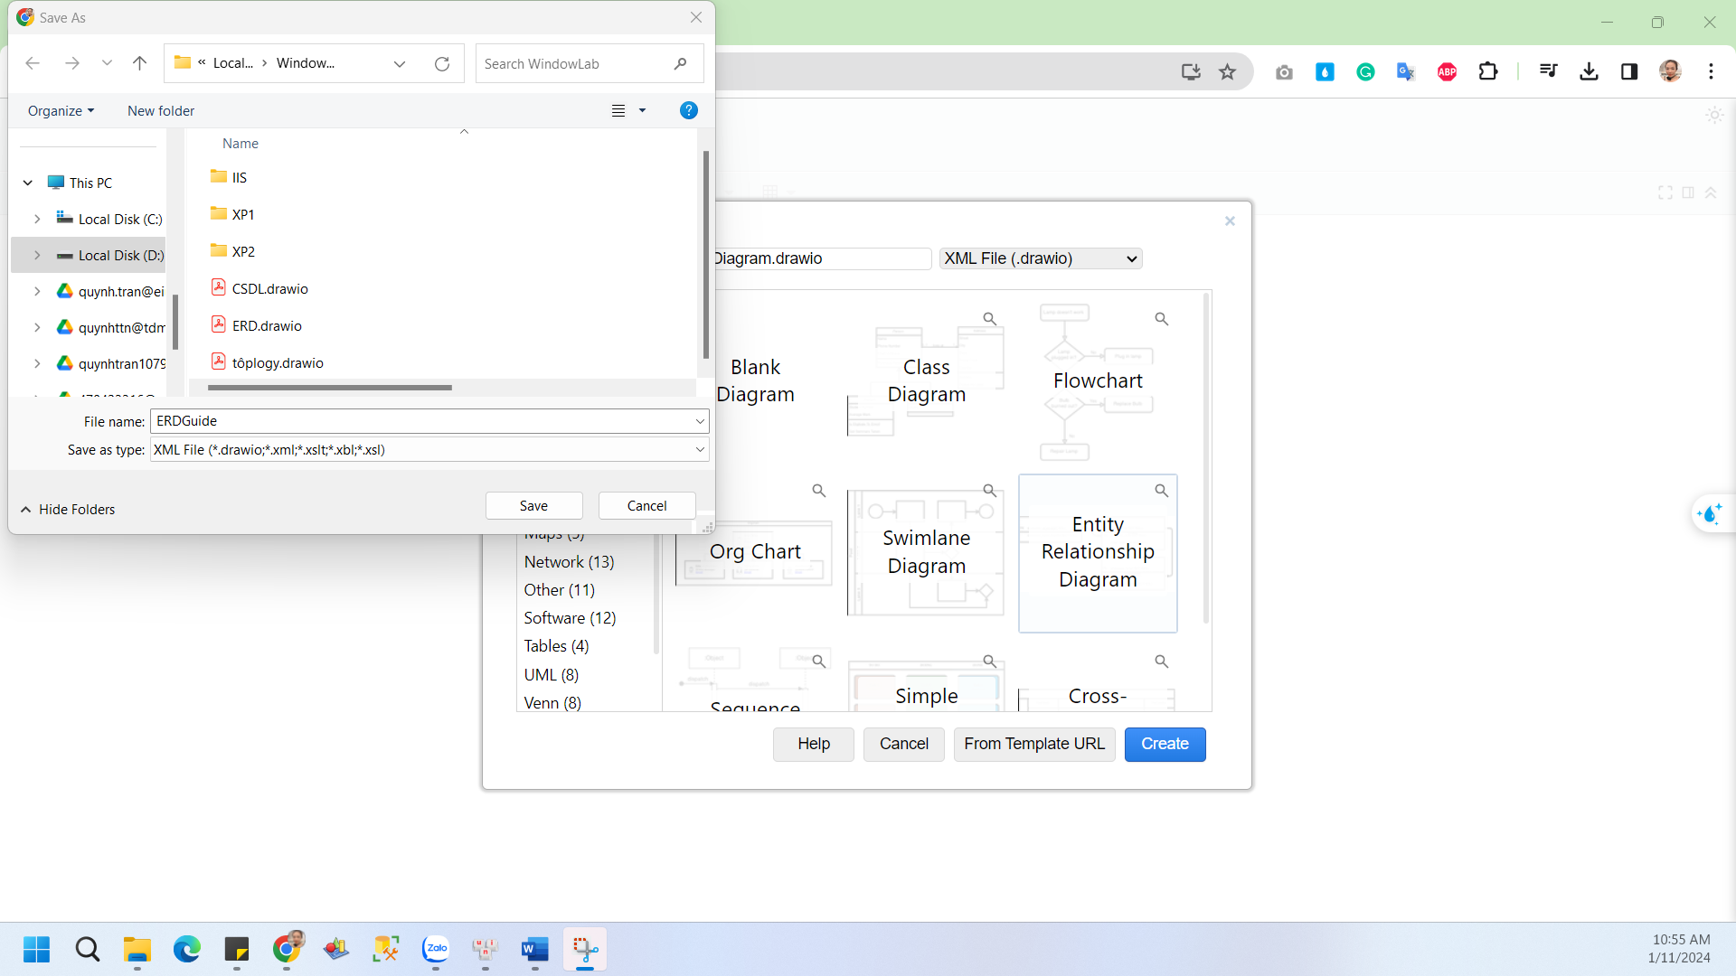
- Ctrl + A -> Deleting all of the things you don’t use -> Finding in Left tab and Choosing “Entity Relation” – in this, including all of icon to draw ER diagram.
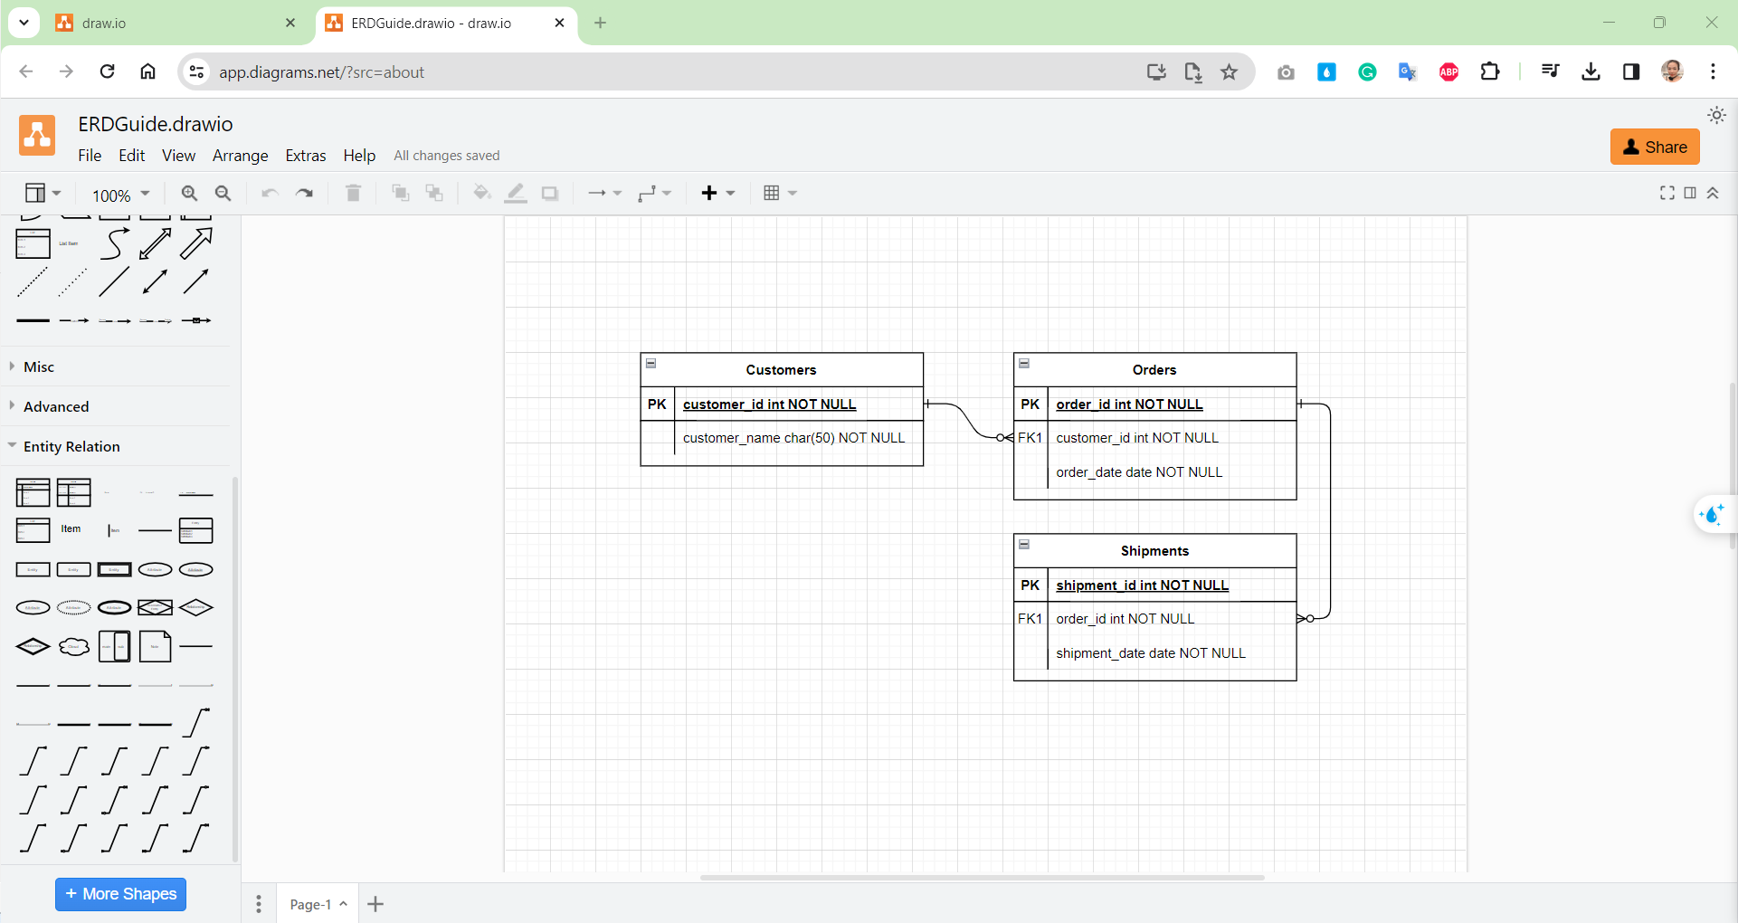
Delete all
- Guiding to use icon for drawing ER Diagram:
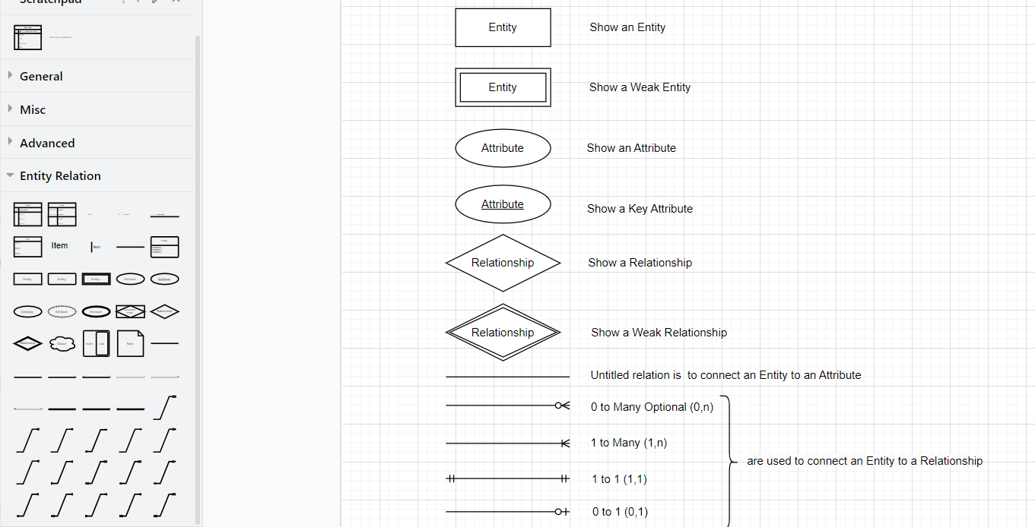

Using draw.io to solve the problems below:
Guide:
- Finding Entities, key Attributes and related Attributes
- Finding Relationships
- Finding weak Entities and weak Relationships (if any)
- Draw an ER model

Problem 1. Building an ER model from Database Schema
CUSTOMERS (CUSTOMERID, FULLNAME, ADDRESS, PHONE, BIRTHDAY, SALE, REGISTRATIONDATE)
New words: Customer relationship will store information of member customers including attributes: customer ID, full name, address, phone number, date of birth, registration date and sales (total value of invoices of this member customer).
STAFF (STAFFID, FULLNAME, DAYOFENTRY, PHONE)
New words: Each salesperson needs to write down their full name, date of entry, contact phone, each employee distinguishes each other by employee code.
PRODUCTS (PRODUCTID, PRODUCTNAME, UNIT, NATION, PRICE)
New words: Each product has a code, an appellation, unit, country of manufacture and a selling price.
INVOICE (INVOICEID, PURCHASEDATE, CUSTOMERID, STAFFID, VALUE)
New words: When purchasing, each customer will receive a bill, which will contain the invoice number, the date of purchase, which employee sells, how much the invoice is worth and the customer's number if a member customer.
DETAILOFINVOICE (INVOICEID, PRODUCTID, QUANTITY)
New words: Explain in detail what products are included in each invoice and in what quantity.

Problem 2: Draw ER Diagram, then in change to Database Schema
An industry company requires employee management by computer. The company has many employees. Each employee is recorded with Full Name: Middle Name and First Name, has a unique code, has date of birth, address, gender, will be in charge directly by a manager (also an employee) and belong to a single department.
Salaries for employees are determined based on their working positions: full-time employees receive a salary according to company policies, while part-time employees are paid based on their working hours, according to rules pay rates.
In the company, there are many departments to manage employees. Each department has a unique code, with a room name, that oversees a certain employee, and records the whole day that the manager starts in charge of the department. Besides, each department can have one or more locations.
The company will implement different projects. Therefore, each project records the code and name of the project, the location of the project implementation.
The department will be assigned and perform the different projects. Each employee can participate in many different projects, and each project can be participated in by many employees.
When an employee joins a project, that employee code, that scheme code, as well as the employee's working time for the project in a week will be recorded.
To pay more attention to the employees, the company will record some information about the relatives of the employees. The names, dates of birth and relationships of relatives will be recorded.

